Zoological Curator 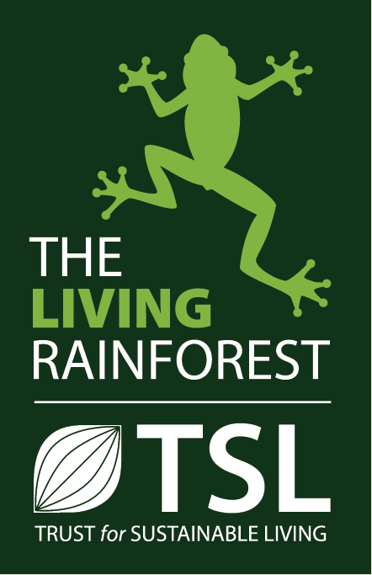
The Living Rainforest and the Trust for Sustainable Living are Co-Authors in a vision that combines 3 glasshouses providing a unique, sensory and immersive experience creating wonder and curiosity about the environment and life sciences with a mission to inspire the next generation to reach out to a sustainable future though imagination and leadership. Our Educational charity ensures that we are a highly sought after centre for schools right across the South of England and our Zoological team provide the canvass on which we all work
The Living Rainforest Centre has a highly talented, knowledgeable and enthusiastic zoological team who maintain the animal collection and constantly review the collections management, standards and practices. Equally importantly they develop our collection to offer a unique blend of taxa diversity and an authentic rainforest feel to ensure our visitors have an inspiring visit.
This is a great opportunity to work with a wide variety of species from Mammals, Reptiles and Amphibians to Fish and Invertebrates. This is a perfect first step for a senior keeper to gain curatorial experience.
The Role
As Curator you will lead a dedicated and enthusiastic team
- to ensure the highest standards of animal husbandry, welfare and exhibit
- Overseeing budgets and developing conservation projects in keeping with the ethos of the organisation
- Oversee department staff and volunteer development, training and evaluation both in animal management and customer service
- Develop public engagement
- Set and implement protocols to allow safe and legal functioning of the department and maintain welfare standards.
- Implement all developing zoo and other relative legislation (including Zoo license, CITES, BALAI, Article 30 and 10, records and more)
- The team is small so this is a hands-on role which is both fulfilling and challenging

The successful candidate will have

- Relevant degree and preferably, a higher degree
- 5 years (ever increasing responsibility) within a zoo environment
- Senior keeper status with managerial experience
- Experience of a diversity of taxa, husbandry and management of animal exhibits and facilities within a themed environment
- Strong leadership skills and the ability to build strong working relationships across teams

To apply
Please send current CV and covering letter to:
Paula Rhoads
Living Rainforest
Hampstead Norreys
RG18 0TN

Or: Finance@livingrainforest.org

