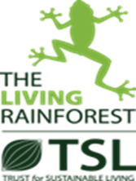
CONSERVATION POLICY FOR THE LIVING RAINFOREST

Background
The Living Rainforest is a small zoo run by the Trust for Sustainable Living. The zoo operates as a licenced zoo and an institutional collection plan determines the species kept. Currently The Living Rainforest has 11 species of invertebrate, 9 species of fish, 5 species of amphibian, 15 species of reptile, 9 species of bird, 5 species of mammals and 850 plant species including rare aroids and orchids. The Trust for Sustainable Living (TSL) is a global sustainability education charity, based at the Living Rainforest. Our Vision is ‘A world in which everyone is educated and empowered to achieve a sustainable future’.
Education
Our International Debates and Education Summits provide a platform for youth discussions on topical sustainability and environmental issues and how they might be addressed, as well as providing an opportunity for students and teachers interested in ESD to engage with governments, scientists, and experts on topics from sustainable cities to protecting the oceans and addressing climate change. As well as our international education work, we welcome 100,000 visitors annually to experience the sights, sounds and smells of a tropical rainforest at our Living Rainforest education centre, including 25,000 school children who visit for our award winning, curriculum linked educational tours exploring the links between rainforests and sustainability. TSL are in a unique position to engage large numbers of national and international young people, and the teachers who support them, which enables us to ‘Connect young people to resources and activities that educate and empower them to create a more sustainable world’. TSL aims to continue providing support, inspiration, empowerment, and a platform for youth and teacher engagement in ESD and to broadcast youth voices to a wider international audience, enabling them to become part of the solution.
Sustainability
Our Education Centre – The Human Impact building opened in 2006 incorporating sustainable materials, low embodied energy, passive/natural ventilation, passive solar gain, and a small photovoltaic solar array. The Living Rainforest is committed to becoming more sustainable and reducing its carbon footprint. The aim is to be carbon neutral by 2030. A huge task considering we heat a tropical house in Berkshire to replicate a tropical rainforest. Our lead heating system is a biomass boiler that has reduced our carbon footprint by about 220 tonnes of CO₂ each year since 2006. In addition, we have just replaced our back up kerosine boiler with state-of-the-art hydrogenated vegetable oil (HVO) condensing boilers. Using HVO compared with the traditional boiler will save significant levels of CO₂ emissions, as well as significantly reduce nitrogen oxide (NOx), particulate matter (PM) and carbon monoxide (CO) emissions. In 2023 we replaced the majority of our thermal screens in our glasshouses for more energy efficient versions.
Further projects to reduce our carbon footprint include better insulation for the tropical houses, installation of solar photovoltaic panels, solar water heating and both air source and ground source heat pumps. These future projects are funding dependant.
The Plant Department does not use any chemical pesticides to control glasshouse pests, instead, bio- controls such as natural predators and parasites are used. Rainwater Harvesting is used to collect water for irrigation and minimising the use of mains water, thus reducing our carbon footprint. There is storage for 30,000 litres of rainwater.

Sustainability in the café is of paramount importance. As far as possible products are sourced from local suppliers. These include all the fresh meat products i.e., sausages, burgers, and sausage rolls from local farm shop, and salad items from a local fruit & veg wholesaler. For the general groceries I use 2 smaller scale local foodservice companies. Our coffee is Rainforest Alliance and blended for us by a family run local firm which also supplies all the teas which are fairtrade. Most of our cakes are made by a local bakery. Wherever possible the products are zero palm oil or RSPO. A good percentage of the stock is now plant based and use an ethical supermarket for the crisps, snack bars and baby foods.
In the shop we stock a selection of chocolate made by a small independent company and completely palm oil free, the rest of the food/sweet items in the shop are either palm oil free or RSPO and fairtrade. We also sell many items which are fairtrade or support projects locally and around the world, i.e., cleaning up the oceans, building schools in Peru, supporting ending girl slavery. Most of the soft toys we stock are now part or fully made from recycled materials. We have a range of scarves made from recycled plastic bottles. All the eco range is sourced locally along with some of our jewellery.
The animal department has also improved it sustainability by receiving left over food from a local fruit and vegetable wholesalers. This prevents the food from going to landfill. Leftover food from our animals is offered to a local pig farmer. We will be looking to start to growing salad crops and vegetables for the animal department during 2023/24.
Since 2011, our annual International Schools Essay and Video competitions have engaged over 14,000+ students and 2000+ teachers in 80 countries to explore and share their voices on a variety of challenging global sustainability issues such as preventing biodiversity loss, how to protect life in our oceans and how to make our cities truly sustainable.

Habitat Management
The Plant Department works with other botanic gardens to actively manage outdoor spaces to encourage plant and habitat conservation. The planting and seeding of wildflowers around our outdoor spaces is appropriate to West Berkshire. The department also works to ensure the ethical and sustainable sourcing of all plant material, the use of peat free compost and no pesticides are used onsite.
Composting is carried out to encourage native reptiles such as slow worms. Areas of nettles, bramble and native flowers and grasses are left to encourage butterflies and other native invertebrates. Logs piles are placed in unused areas to encourage invertebrates, amphibians, reptiles and mammals. Bioblitz are carried out annual (Pre covid) and all sightings recorded and sent to local records centre. Any other unusual sightings are recorded and sent via IRecord or INaturalist.

Partnerships
We partner with the following groups, Global Youth Biodiversity Network (youth arm of CBD) and YOUNGO (youth arm of UNFCCC) as part of our education summits and biodiversity scientists taking part on our Protecting Biodiversity summit from Future Earth. We partnered with Conservation Without Borders (CWB) in 2021 on our sustainability challenge video competition asking people to send us 1 minute videos to world leaders on ‘the need to combat the climate crisis and drive a green revolution’. CWB shared the winning videos at COP26 for us. They also did a session at our Protecting Biodiversity Summit to talk about her biodiversity protection work with migratory species and the Round Britain Climate Challenge. We are currently partnering with them to create educational resources to support the flight of the osprey expedition which will happen Aug-Nov 2022. We will have a series of lesson plans and activities, fact sheets and PowerPoints on Ospreys and we are hoping to connect the researchers on the expedition with schools we work with on the trip route so they can do some activities with the school kids. That’s also working with WWT and international wetland centres – Bird Center Urdaibai, Wetlands International, EVOA.

We partnered with ZooLab to run the virtual Kids COP26 online summit which gave 25 kids from 13 countries the chance to explore, debate and discuss 8 key areas impacting and impacted by climate change. We also created and delivered a joint ‘Climate and Nature’ online lesson, further exploring the issues put forward by the students in the Kids COP26 Summit, which covered the problem, impacts and potential solutions. The videos of the Kids COP, Climate and nature lesson, sustainability challenge and the protecting biodiversity summit are all available on out TSL Youtube and the new TSL community platform as learning resources. We also helped in the creation of a COP26 education pack with all the organisations in the logo below which has had over 90k downloads in the UK.
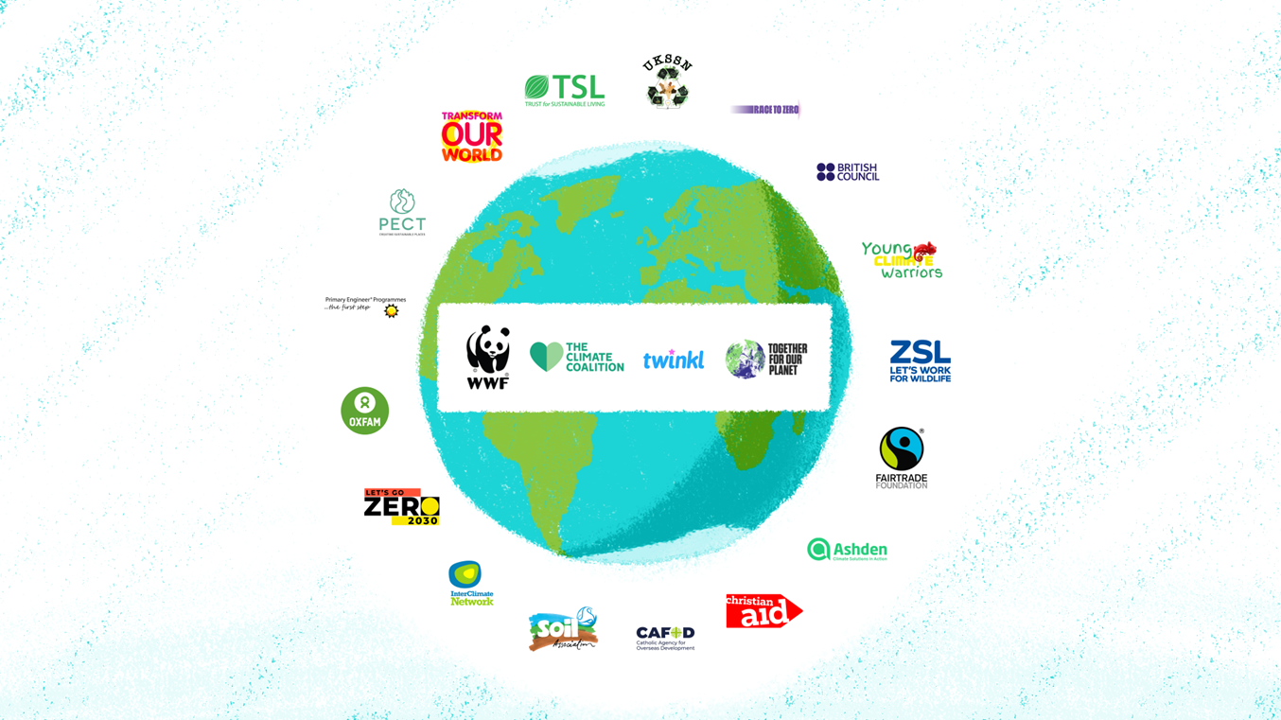

The Plant Department have been members of Botanic Gardens Conservation International (BGCI) for many years and regularly swaps plants with Royal Botanic Gardens Kew, and The Eden Project. The Animal department have links with Sparsholt University College Centre and many local further education colleges offering work placements and research opportunities to their students.

